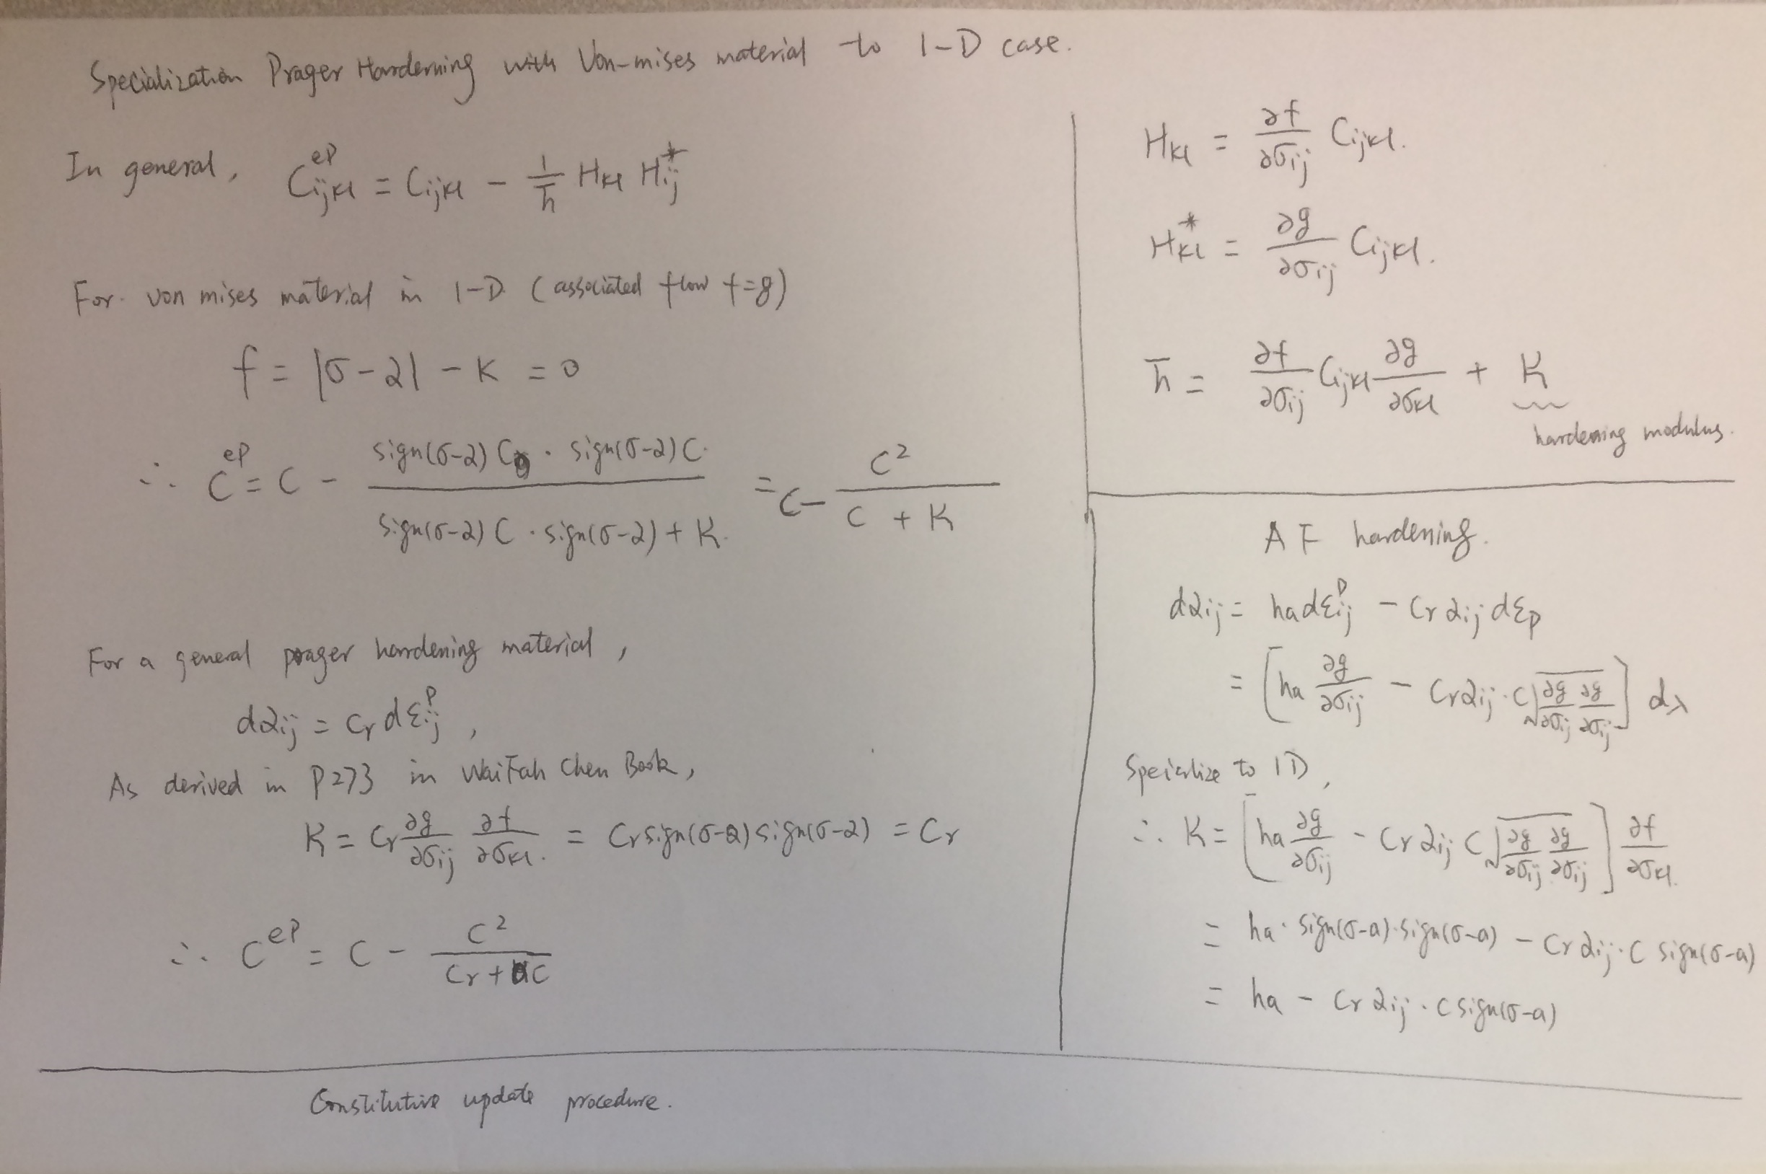
The constitutive update procedure is based on Page 311 of Waifah Chen’s book.

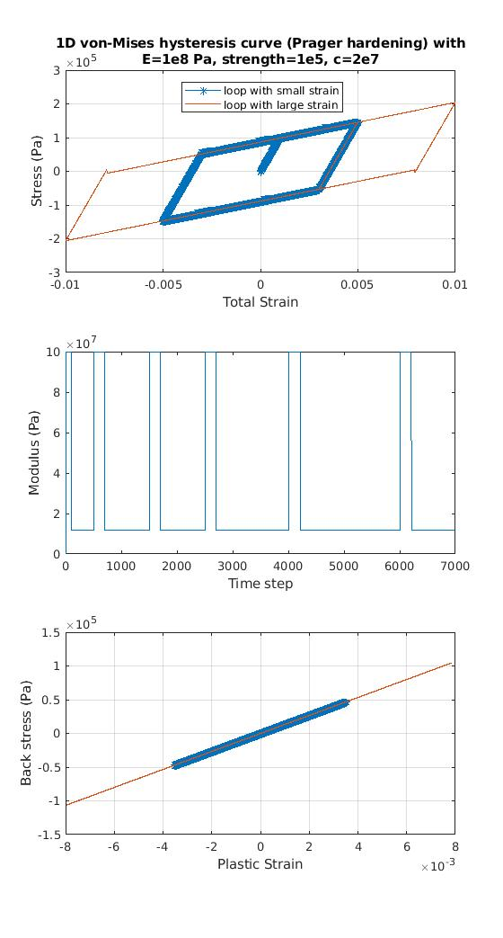
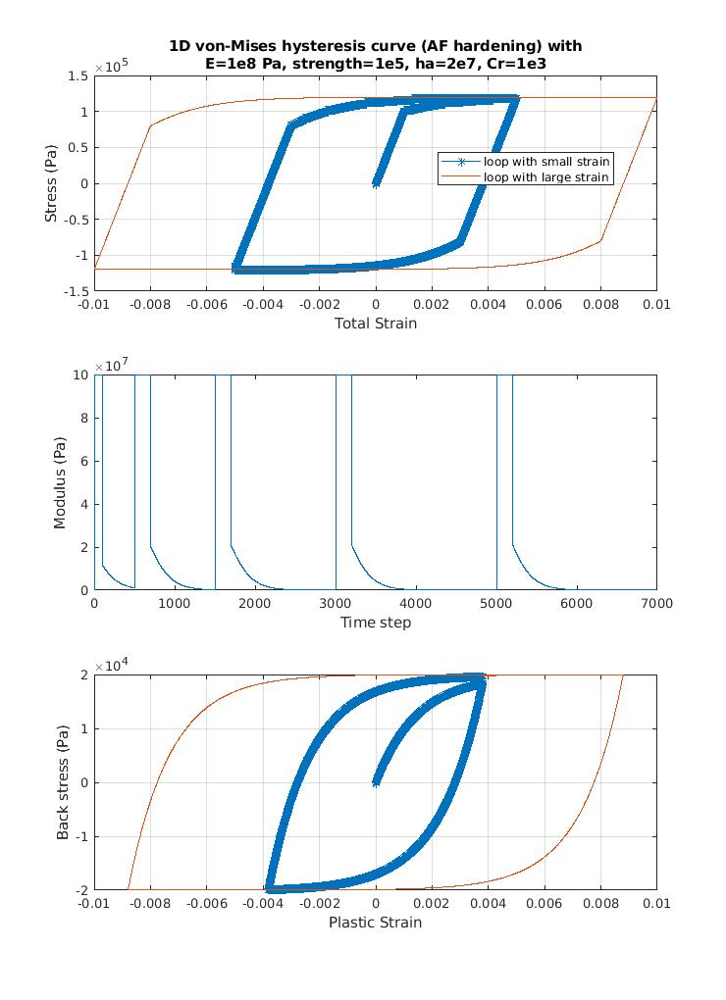
Code for Prager Hardening:

%%

clc;clear;
inc_strain=[ 0.00001*ones(1,500)...
-0.00001*ones(1,1000) 0.00001*ones(1,1000) ...
-0.00001*ones(1,1500) 0.00001*ones(1,2000) ...
-0.00001*ones(1,1000)];
E=1e8; % unit:Pa
yield_tag=0;
strength=1e5;
ha=2e7;

stress=zeros(1,length(inc_strain));
total_strain_pl=zeros(1,length(inc_strain));
alpha=zeros(1,length(inc_strain));

for i=2:length(inc_strain)

if yield_tag==0
trialstress=stress(i-1)+E*inc_strain(i);
if abs(trialstress)< abs(strength+ sign(trialstress)*alpha(i-1))
E_ep=E;
stress(i)=trialstress;
total_strain_pl(i)=total_strain_pl(i-1);
yield_tag=0;
alpha(i)=alpha(i-1);
else
E_ep=E;
stress(i)=sign(trialstress)*(strength+ sign(trialstress)*alpha(i-1));
total_strain_pl(i)=total_strain_pl(i-1);% + (trialstress-strength+alpha(i-1))/E;
yield_tag=1;
alpha(i)=alpha(i-1);
end
else
L=sign(stress(i-1)-alpha(i-1))*E*inc_strain(i);
if L<0
E_ep=E;
stress(i)=stress(i-1)+E_ep*inc_strain(i);
total_strain_pl(i)=total_strain_pl(i-1)-inc_strain(i);
yield_tag=0;
alpha(i)=alpha(i-1);4
else
E_ep=E-E*E/(E+2/3*ha);
stress(i)=stress(i-1)+E_ep*inc_strain(i);
inc_strain_pl=E/(E+2/3*ha)*inc_strain(i);
total_strain_pl(i)=total_strain_pl(i-1) + inc_strain_pl;
yield_tag=1;
alpha(i)=alpha(i-1)+2/3*ha*inc_strain_pl;
i
end

end

total_E_ep(i)=E_ep;

end

%%

subplot(3,1,1)
total_strain=cumsum(inc_strain);
plot(total_strain(1:2500), stress(1:2500), '-*'); grid on; hold on;
plot(total_strain(2500:end), stress(2500:end), '-'); grid on;
xlabel('Total Strain'); ylabel('Stress (Pa)')
legend('loop with small strain', 'loop with large strain')
title({'1D von-Mises hysteresis curve (Prager hardening) with', 'E=1e8 Pa, strength=1e5, c=2e7'})

subplot(3,1,2)

plot(total_E_ep);
xlabel('Time step'); ylabel('Modulus (Pa)');

subplot(3,1,3)

plot(total_strain_pl(1:2500), alpha(1:2500), '-*'); grid on; hold on;
plot(total_strain_pl(2500:end), alpha(2500:end)); grid on; hold on;

xlabel('Plastic Strain'); ylabel('Back stress (Pa)');

Code for AF hardening:

%%

clc;clear;
inc_strain=[ 0.00001*ones(1,500)...
-0.00001*ones(1,1000) 0.00001*ones(1,1000) ...
0.00001*ones(1,500) -0.00001*ones(1,2000) 0.00001*ones(1,2000)];
E=1e8; % unit:Pa
yield_tag=0;
strength=1e5;
ha=2e7;
Cr=1e3;

stress=zeros(1,length(inc_strain));
total_strain_pl=zeros(1,length(inc_strain));
alpha=zeros(1,length(inc_strain));

for i=2:length(inc_strain)

if yield_tag==0
trialstress=stress(i-1)+E*inc_strain(i);
if abs(trialstress)< abs(strength+ sign(trialstress)*alpha(i-1))
E_ep=E;
stress(i)=trialstress;
total_strain_pl(i)=total_strain_pl(i-1);
yield_tag=0;
alpha(i)=alpha(i-1);
else
E_ep=E;
stress(i)=sign(trialstress)*(strength+ sign(trialstress)*alpha(i-1));
total_strain_pl(i)=total_strain_pl(i-1); % + (trialstress-strength+alpha(i-1))/E;
yield_tag=1;
alpha(i)=alpha(i-1);
end
else
L=sign(stress(i-1)-alpha(i-1))*E*inc_strain(i);
if L<0
E_ep=E;
stress(i)=stress(i-1)+E_ep*inc_strain(i);
total_strain_pl(i)=total_strain_pl(i-1)+inc_strain(i);
yield_tag=0;
alpha(i)=alpha(i-1);
else
E_ep=E-E*E/(E+2/3*ha-2/3*Cr*alpha(i-1)*sign(stress(i-1)-alpha(i-1)));
stress(i)=stress(i-1)+E_ep*inc_strain(i);
inc_strain_pl=(1-E_ep/E)*inc_strain(i);
total_strain_pl(i)=total_strain_pl(i-1) + inc_strain_pl;
yield_tag=1;
alpha(i)=alpha(i-1)+2/3*ha*inc_strain_pl - 2/3*Cr*alpha(i-1)*abs(inc_strain_pl) ;
i
end

end

total_E_ep(i)=E_ep;

end

%%

subplot(3,1,1)
total_strain=cumsum(inc_strain);
plot(total_strain(1:2500), stress(1:2500), '-*'); grid on; hold on;
plot(total_strain(2500:end), stress(2500:end), '-'); grid on;
xlabel('Total Strain'); ylabel('Stress (Pa)')
legend('loop with small strain', 'loop with large strain')
title({'1D von-Mises hysteresis curve (AF hardening) with', 'E=1e8 Pa, strength=1e5, ha=2e7, Cr=1e3'})

subplot(3,1,2)

plot(total_E_ep);
xlabel('Time step'); ylabel('Modulus (Pa)');

subplot(3,1,3)

plot(total_strain_pl(1:2500), alpha(1:2500), '-*'); grid on; hold on;
plot(total_strain_pl(2500:end), alpha(2500:end)); grid on; hold on;

xlabel('Plastic Strain'); ylabel('Back stress (Pa)');

